Pythagoras' Theorem

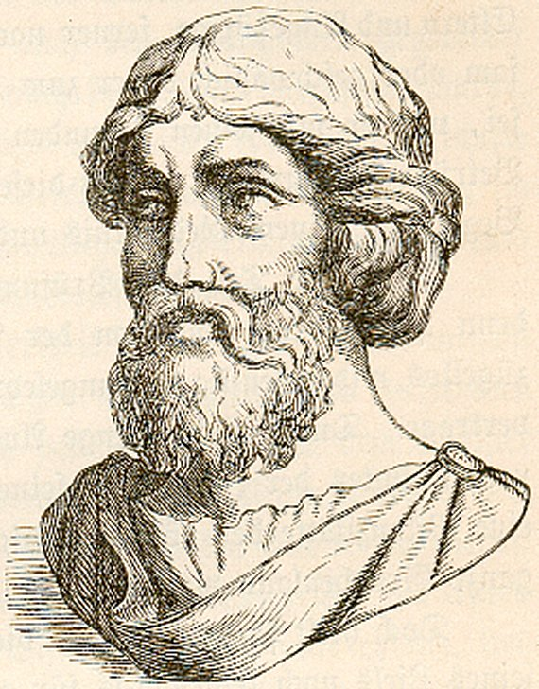
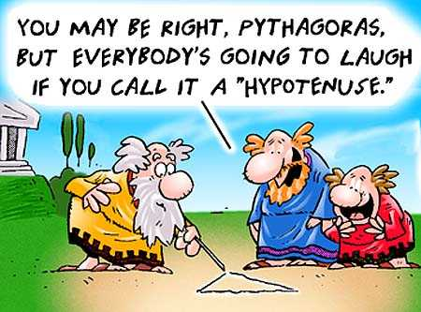

a and b are the shorter sides in a right angled triangle
c is the longest side, the hypotenuse

What does it tell us?
→ It tells us the link between the lengths of the sides on a right angled triangle, linking geometry and algebra
What did it lead to?
→ It led to calculating distances between places without actually having to measure them, as well as the most accurate current theories of space, time, and gravity…

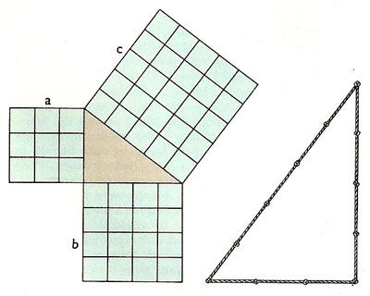

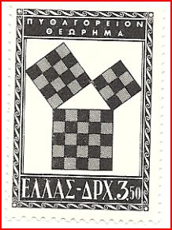

Logarithms

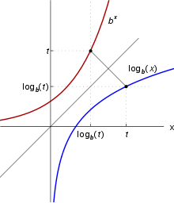

The logarithm of x times y
Is equal to
The logarithm of x add the logarithm of y

What does it tell us?
→ It tells us how to multiply numbers by adding related numbers instead

What did it lead to?
→ Ways to quickly calculate planetary orbits, radioactive decay, and rates of growth. Accurate ways to measure the strength of earthquakes. It also led to the slide-rule (a predecessor to the calculator!)

Calculus

Change in value of new quantity

Rate of change of quantity

With respect to time
Is limited as time approaches 0
Time interval

What does it tell us?
→ It tells us how to find the way in which an object changes at any given moment in time, such as the speed of a car
What did it lead to?
→ Formulae for the volume of solids, Isaac Newton’s laws of motion, the law of the conservation of Energy (used by Einstein). Almost all the maths in physics is based around calculus…

Newton's Law of Gravity
Mass of object 1
Mass of object 2

The attractive force

The Gravitational constant
The square of the distance between them

What does it tell us?
→ It allows us to work out the gravitational force between two objects, based on their masses and the distance between them

What did it lead to?
→ Allowed the prediction of eclipses and planetary orbits, the building of satellites that mobile phones now rely on. Increased space exploration and Global Positioning Systems (GPS).

Euler's Formula for Polyhedra

Number of faces
Number of edges
Number of vertices

What does it tell us?
→ The number of Faces, Edges and Vertices of a solid are related in a very simple manner

What did it lead to?
→ A new branch of Maths called ‘Topology’, the study of 3D objects. The ideas from this are used to explain how enzymes affect DNA and why the motion of celestial bodies is chaotic…

The Square Root of Minus One

What does it tell us?
→ That the square of the number i is -1, even though this is impossible!
What did it lead to?
→ It led to the creation of imaginary and complex numbers, which are used to explain waves, heat, electricity, and magnetism. It is also used by physicists to explain quantum mechanics…

The number we are getting
Raised to the power
The Normal Distribution
The mean
The probability of getting number x

Standard Deviation

Pi (3.14159…)
Standard Deviation
‘e’ (2.71828…)

What does it tell us?
→ It tells us that the probability of observing a particular value of data falls greatly as it moves away from the mean (ie) The chance of seeing a very tall person is very low!
What did it lead to?
→ The ability to test whether medical trials were accurate or biased, ways to calculate the cost of insurance, advanced probability theories, IQ tests

The Wave Equation

The second partial derivative of displacement, with respect to time
The second partial derivative of displacement, with respect to space

Speed squared

What does it tell us?
→ The acceleration of a violin string is proportional to the average displacement of neighbouring segments (a shorter string has a higher pitched sound)
What did it lead to?
→ The understanding of how light, sound and water based waves work. Oil companies use the idea to detect whether there is oil beneath the surface, based on vibrations. It predicted the possibility of radio waves

The Fourier Transformation
Frequency
3.14..
Root -1
Frequency
The transformation of this function

What did it lead to?
→ The idea is used in data compression, allowing big files to be reduced in size to save space. It can also repair damaged audio/video recordings. It is also used by the police to store fingerprint data very efficiently.

2.718…

The integral from infinity to minus infinity

Space

What does it tell us?
→ Any pattern in space and time can be thought of as a superposition of sinusoidal patterns with different frequencies (all waves can be made up of different ‘standard’ waves combined with each other)

The Navier-Stokes Equation
Velocity
Density
Pressure
Stress
Body forces

What does it tell us?
→ It is Newton’s second law of motion. The left hand side is the acceleration of a fluid. The right hand side is the forces on it, pressure, stress, and internal bodies
What did it lead to?
→ The calculation of how fluids move, jet aeroplanes, racing cars that can move fast but stay on the ground. Medical experts can model how blood should flow in a patient and find problems if it is flowing incorrectly

Time derivative
Dot Product
Divergence
Gradient

Maxwell's Equations

Change in magnetic field with respect to time

Electric Field
Divergence = 0
Speed of light
Magnetic Field
Curl
Change in electric field with respect to time

What does it tell us?
→ That electricity and magnetism do not ‘leak away’, and that spinning electric fields create magnetic fields, and vice versa
What did it lead to?
→ It unified theories on electricity and magnetism into an overall picture of how they work. It predicted the existence of electromagnetic waves other than light, leading to radio, radar, and wireless computing

The Second Law of Thermodynamics
Change in
Entropy (to do with energy distribution)
Is greater than or equal to
Zero

What does it tell us?
→ That disorder in a thermodynamic system is always increasing (if you pour some orange squash, it will always become more and more evenly mixed, rather than separating out again)
What did it lead to?
→ It allowed calculations of the limit of work done by heat (such as in generating electricity). It led to more efficient steam engines and proof that all matter is made up of atoms

Relativity

Rest energy of matter
Mass
Speed of light squared

What does it tell us?
→ Matter contains energy equal to its mass multiplied by the speed of light squared (a tiny amount of matter contains lots of energy!)

What did it lead to?
→ It led to Nuclear Fission and efficient ways to generate large amounts of electricity. The theory of the big bang and the start of the universe, the prediction of the existence of Black Holes, accurate satellite navigation systems

Schrödinger's Equation
Hamiltonian operator
Root -1

Planck’s constant divided by 2π
Quantum wave function

Rate of change with respect to time

What did it lead to?
→ It led to quantum theory, and the development of even smaller computer chips. Lasers (Light Amplification by Stimulated Emission of Radiation) are also based on the theory
What does it tell us?
→ It tells us how matter can be modelled as a wave instead of a particle

Information Theory

Amount of information
Probability of x multiplied by the logarithm of the probability of x
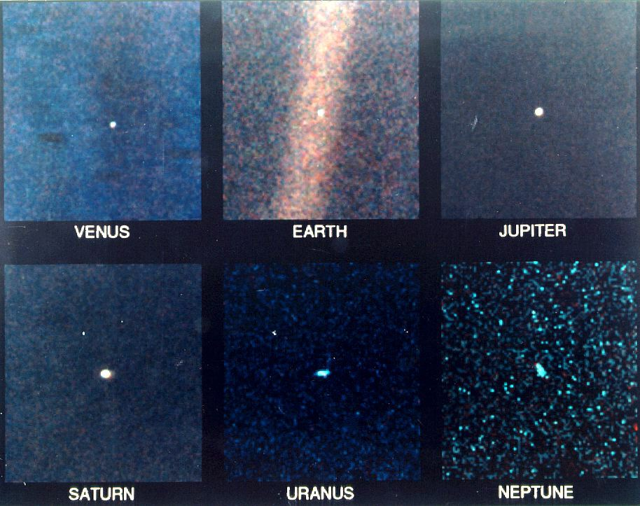
Sum of

What does it tell us?
→ It defines the amount of information a message can contain, based on probability

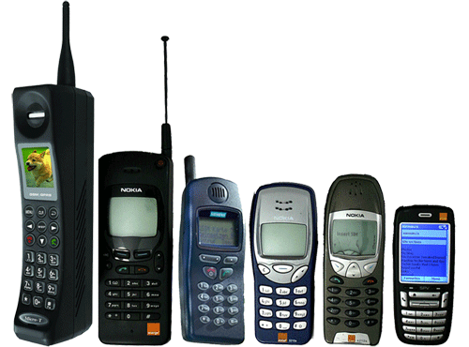

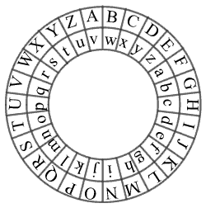
What did it lead to?
→ It led to efficient error detecting codes and ways to correct them (so when you send an email, all the words come out in the right order without being disrupted). It is used in creating artificial intelligence and cryptography, mobile phones

Chaos Theory

unconstrained growth rate

Population size

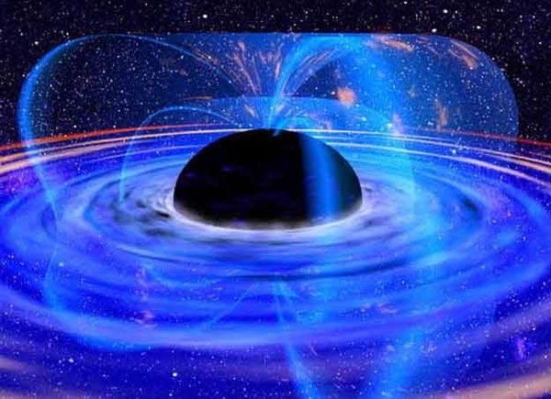


Of the next generation
Population size now
Population size now

What does it tell us?
→ It models how a population of living creatures can change from one generation to the next, when resources are limited

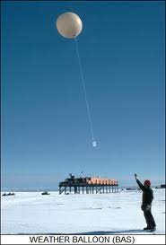


What did it lead to?
→ It led to the idea of Chaos Theory, whereby one tiny change can have big effects elsewhere. The classic example being a butterfly flapping its wings harder could cause a storm. It allowed for better weather forecasting, earthquake modelling, and better trajectories for space probes…

The Black-Scholes Equation
Rate of change of the rate of change
Volatility
Price of the financial derivative



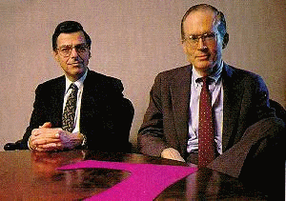

Risk free interest rate
Price of Commodity

What does it tell us?
→ It describes how a financial derivative changes over time, based on the fact that a correct price means it carries no risk and no-one can make a profit on it…
What did it lead to?
→ It led to a huge growth in the financial sector, complex financial modelling tools allowing calculation of risk and reward. It allowed ‘advance trading’, where the value of an object can be calculated before it exists. It unfortunately also led to the economic slump of the 2000-2010s…




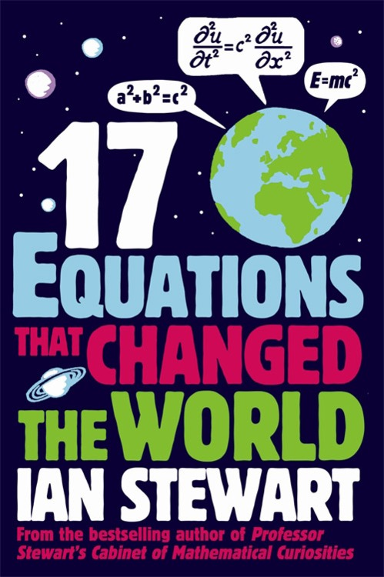
An equation is a bridge. No matter how great the chasm between two ideas on the opposite sides of an "=" symbol might be, an equals sign yokes them together, turning them into something greater. At its heart, an equation is the distillate of humanity's desire to forge links between realms, links that make up the framework that we use to try to make sense of the Universe.

Take, for example, that most famous of equations - and a shoo-in for anybody's list: E = mc². It doesn't take long to grasp what the elements in that equation represent: E stands for the energy of an object, m for its mass, and c represents the speed of light, roughly 300,000 kilometres per second. The form of the equation is childishly simple. However, that simplicity is deceptive. The expression encodes Einstein's realization that mass and energy are not independent, but are in fact intimately related to each other - a realization that has tremendous consequences. The moment when we first figured out a controlled manner by which we could take matter on one side of the equation and convert it to energy on the other side of the equation was the moment when humanity entered the nuclear age. And the equation sits at the heart of the special theory of relativity, which shows that space and time - again, seemingly unrelated ideas - are tied together in completely unexpected ways.

Stewart takes pains to keep his prose understandable for non-mathematicians, in part, by stressing everyday applications of the great equations. For example, when explaining the Fourier transform - a family of equations that allows mathematicians to break a complicated formula down into a set of simple components - he demonstrates how those equations are responsible for the primary scheme that our computers use to render images. Yet it's when he strays away from the concrete that Stewart really gives a glimpse of how deep the rabbit hole goes. In the case of Fourier transforms, the equations provide not just a single way of breaking down mathematical formulae into components but an infinite variety of ways. The mechanics of the Fourier transform allowed later mathematicians to view those formulae as residents of an infinite-dimensional space populated by an uncountable bestiary of exotic functions.

17 Equations that

changed the world

